**CSD 1133 - Group 5  
Term 1 Project**

**Prepared and submitted by: Submitted to:**  
ANDI, Mufida Omar (C0864756) Ahmad Alhamed  
ESPIÑA, Sylvia De La Pena(C0866311)  
LU, Tich Vu (C0861736)  
REDDY, Ajay Ambharapu Kumar(C0865533)  
SHAH, Jay (C0868053)  
VARMA, Jenil Shivamkumar (C0870543)

Purpose of the Website

To allow customers to shop at home with a vast selection of clothing, groceries, kitchen accessories, and well-designed and practical home furnishings at an affordable price so that everyone may afford them without the need to leave the safety of their home since all of these will be delivered at their doorstep.

Target Audience

Our service will be offered to customers aged 12+ in the USA, Canada, and Australia.

Multiplatform Display and Website Pages

The website can be accessed through different browsers, smartphones, and tablets for customers to shop anytime and anywhere.

Graphics

The website will display product options with images, discounted offers, and an area where they can add and checkout orders. Details about the company will also be displayed, including its mission and how and when customers can contact us. A map of the company’s location is also displayed.

Color

The website will use minimalistic colors such as black, white, and yellow to make the customers focus their attention on the products. These colors can also be seen in the company’s logo.

Typography

The website will use a Poppins font style for product lists, paragraphs, and other content to make it easier to read.

Sitemap

The website will have seven pages: Home, Products, About, Contact Us, Cart Check Out, and a Thank You page for the successful placing of an order.

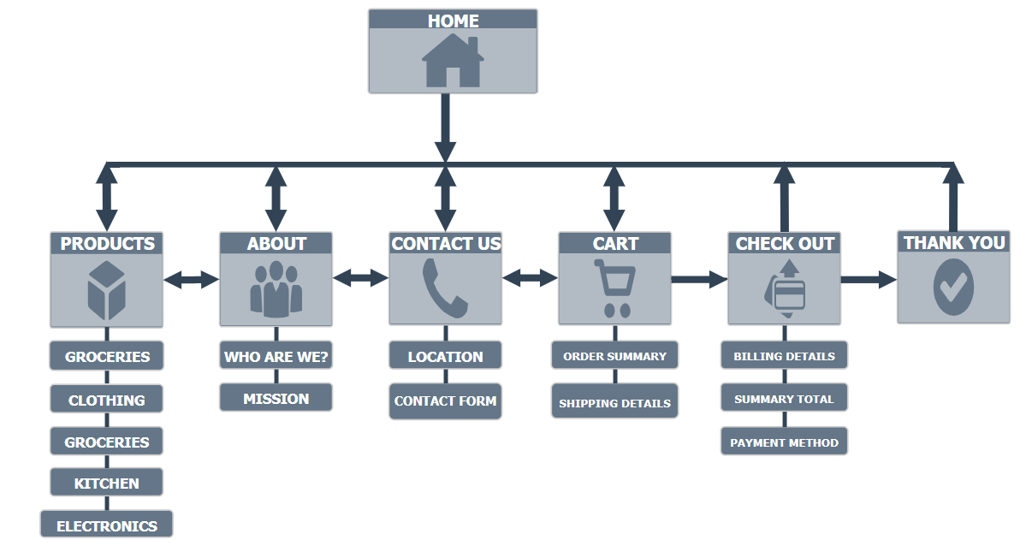

Wireframes

* **WEB**
  + **HOME**

* + **PRODUCTS**

* + **ABOUT**

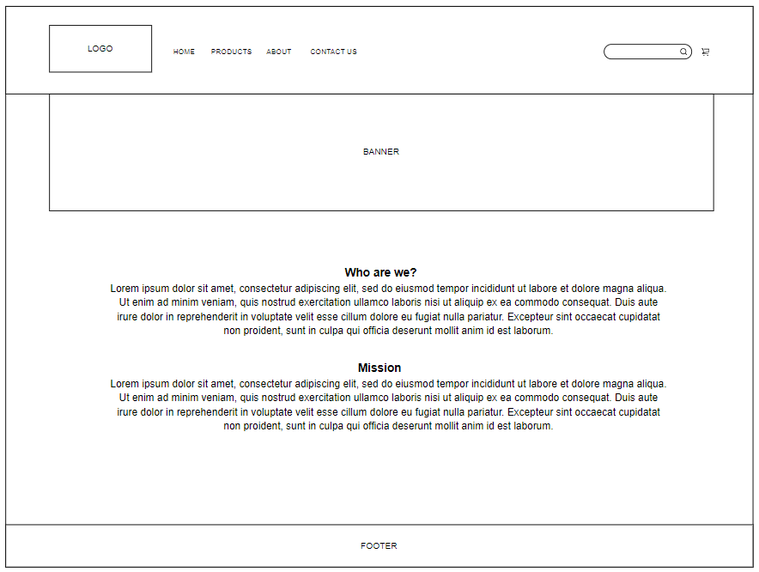

* + **CONTACT US**

* + **CART**

* + **CHECK OUT**

* + **THANK YOU**

* **MOBILE**
  + **HOME**

* + **PRODUCTS**

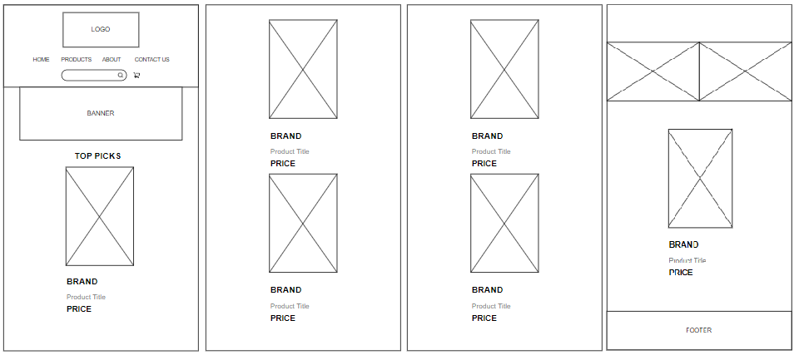

* + **ABOUT**

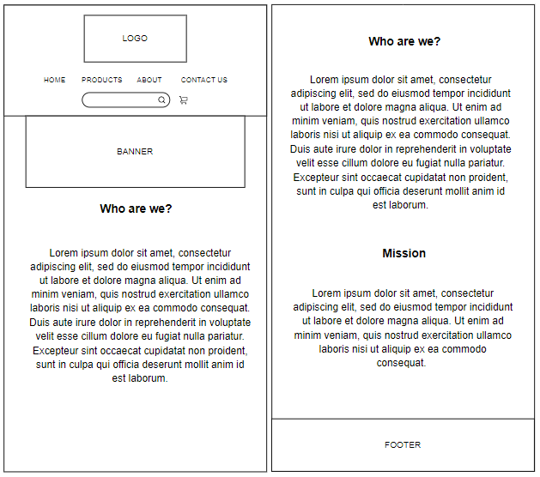

* + **CONTACT US**

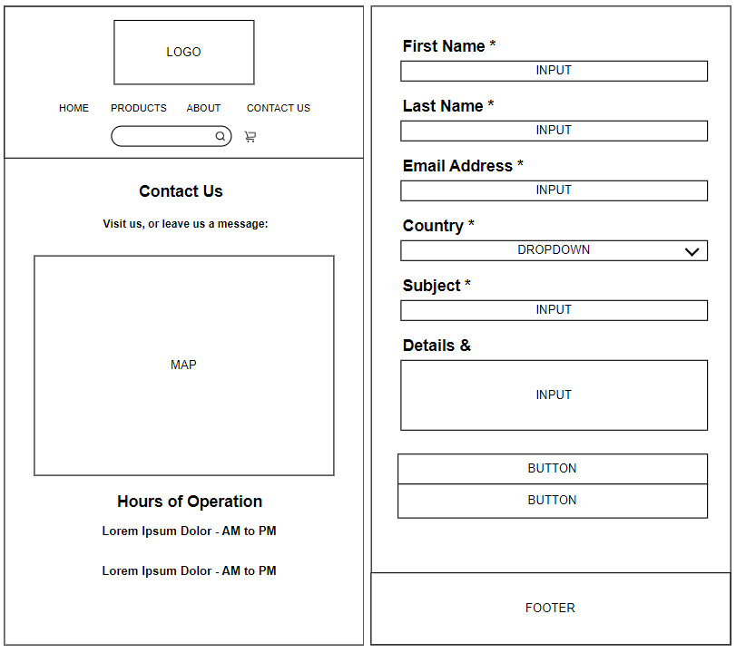

* + **CART**

* + **CHECK OUT**

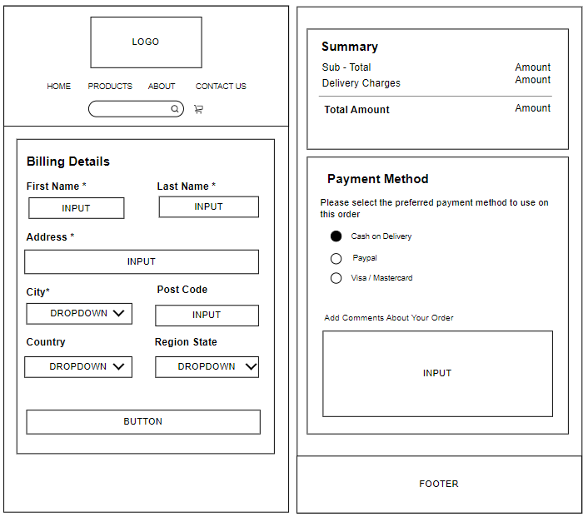

* + **THANK YOU**

* **TABLET**
  + **HOME**

* + **PRODUCTS**

* + **ABOUT**

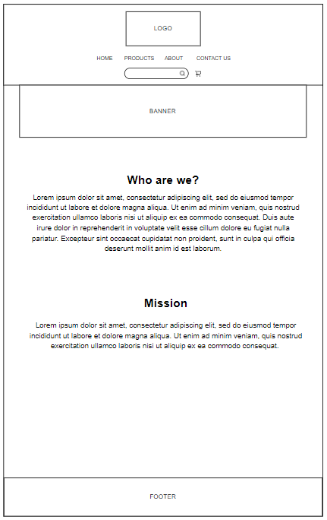

* + **CONTACT US**

* + **CART**

* + **CHECK OUT**

* + **THANK YOU**

